We have teamed up with ‘Into Film’ to be able to provide streaming of some well-loved classics for some special Christmas Movie showings with Mrs Kaminski. All dates are for 2 hours and include a hot chocolate and popcorn- £5 per child - please tick the box to book and return your form to the office! Reception to Year 6 welcome!

Date | Film | Synopsis | I would like to book
Saturday 3rd December 10:00-12:00pm  £5 | Certificate: U | The Polar Express: A young boy is at the age where he's beginning to doubt the existence of Santa Claus. However, one Christmas Eve he hears a thunderous noise outside and, on investigating, finds it's being made by a huge train - the Polar Express. A kindly conductor asks him aboard and soon he and some other children are on a rollercoaster ride north to see the big man himself. Director Robert Zemeckis honed the use of "motion capture" technology when filming The Polar Express, and the technique perfectly suits this charming, fantastical nature of a film about the magic of Christmas.
Thursday 8th December 3:00-5:00pm | Certificate: PG  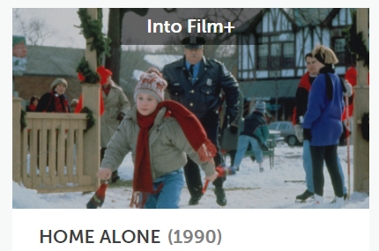 | Home Alone: Kevin (played by famous child star Macaulay Culkin) is an eight-year-old whose parents manage to leave him behind by accident when they fly to France for the Christmas holidays. All by himself in Chicago, he has to think fast when two burglars try to break into the family home. Fortunately, Kevin is great at inventing traps, and the two criminals are extremely stupid, with each attempt to sneak in leaving them in more and more pain and humiliation.
Wednesday 14th December  3:00-5:00pm | 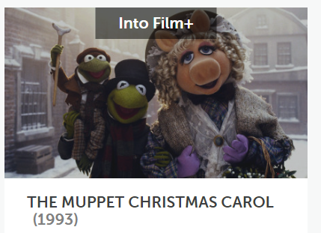  Certificate: U | The Muppet Christmas Carol: Kermit, Gonzo and the rest of the Muppet gang appear in this fun musical take on the classic Charles Dickens story. Ebenezer Scrooge is a miserly and bitter old man with no thought for anyone but himself. One Christmas Eve he is visited by three ghosts - the spirits of Christmas Past, Christmas Present and Christmas Yet to Come - who each show him the error of his ways.
Name of child: |  | Parent signature: | Total cost:

